Price prediction

Future prices are predicted using linear regression, polynomial regression and RBF. Using historical data, we can calculate the prices that would have been predicted at the time and compare them to the actual values. The predictions are put through a genetic algorithm that found the best combination of all three prediction types which resulted in ~97% accuracy (the predicted price deviates from the actual price by ~%3 on average). There is also a fourth prediction type that uses deep learning through a library called Keras.

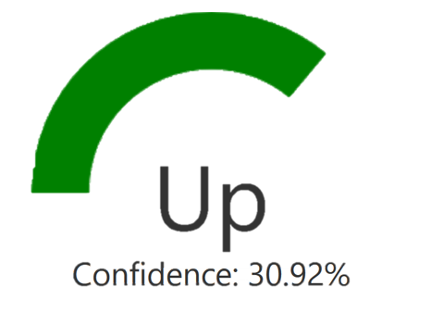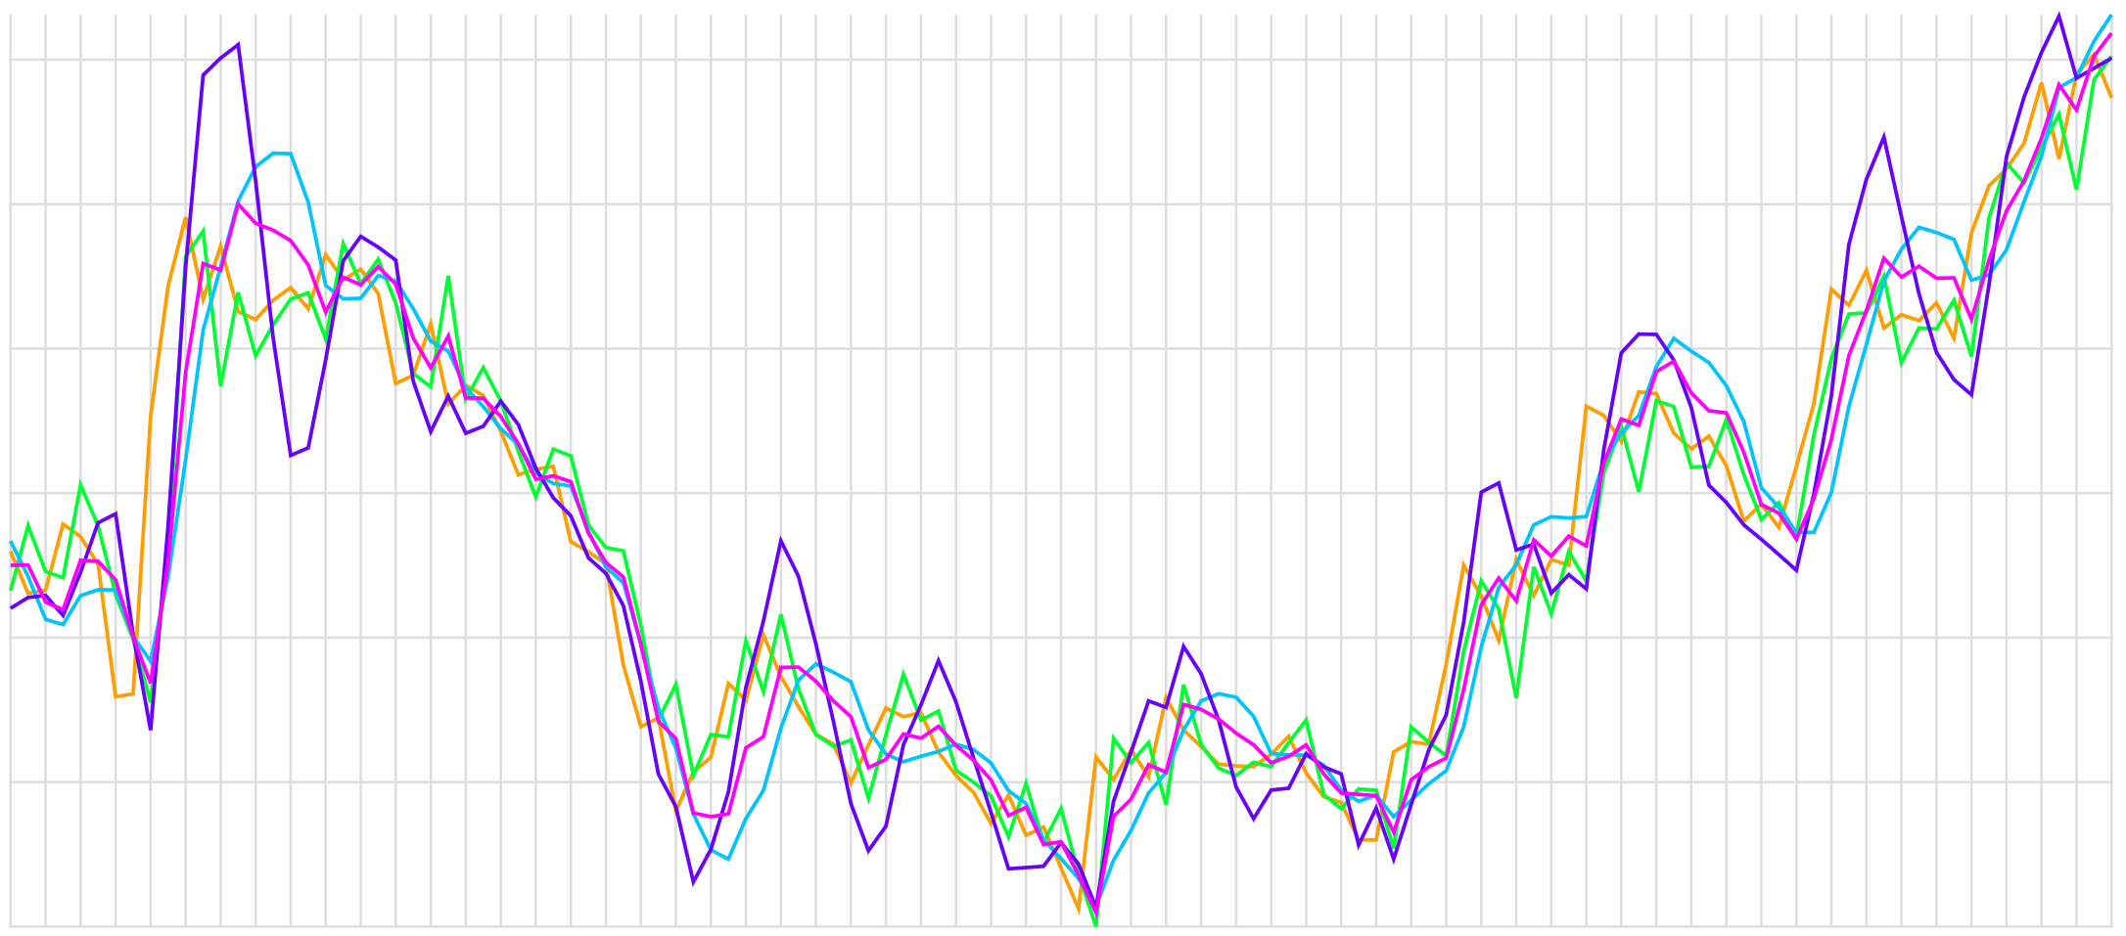

Social Media

* Primary and secondary research has indicated a link between certain social media statistics and the price of cryptocurrencies. For example, volume of Tweets and Bitcoin price.
* Python application streams Tweets and provides users with live analysis of Twitter activity relating to each currency.
* Python function allows users to search Reddit posts between specific dates, and carries out analysis of these posts to display to the user.

Compare with friends

* Brings a competitive vibe to the application
* Compare with other users by searching username
* Privacy setting can be toggled if they don't want their trading portfolio data to be public
* Can be used to improve trading skills in future simulations



This feature brings a competitive vibe to the application where users can see their results compared to another user seeing who ended up in a better position depending on the decisions that they have made which can be used to improve their skills in future simulations. The user can change the settings within their account, to not allow for their results to be retrieved for comparison when searching their username in the application.



Buy/Sell simulation:

* Able to buy an amount of cryptocurrency determined by the user
* Able to sell an amount of cryptocurrency determined by the user
* Table in website that represents all transactions

Chat System:

* Global chat system to communicate with other traders/friends using the same trading platform
* Quick responses
* Provides help/support to users as they can ask questions









Web Crawler:

Python powered web crawler/spider bot that provides users easy access to URLs, text and other necessary data for learning definitions and research into cryptocurrencies, as well as keeping up to date with current news.

Point 1 fine

Point 2 = Azure Function that acquires URL’s, definitions and other information from search engines relating to a given search term.

Also i think the web crawler help page bubble should be called ‘Investing Help Page’ instead

Point 3 = News section providing current URL’s and titles of events impacting cryptocurrencies and trading, using an Azure Function.



Live and Historical Data:

Data collected from CryptoCompare’s API and stored in Azure Table Storage provides quick and efficient access to a wide variety of cryptocurrencies used for charts and simulated positions in investing, all of which updated every 30 seconds on use.

